
FATIMA JINNAH WOMEN UNIVERSITY
RAWALPINDI
Department Of Software Engineering

Cloud Computing Lab

Saira Ejaz [2023-BSE-057]

Section: 5-B

LAB NO 7
Lab Task:
Task 1 — Print & filter environment variables
Goal: Show environment variables and filter them using grep.
Commands and required screenshots (grouped as requested):
- Print all environment variables:
Printenv
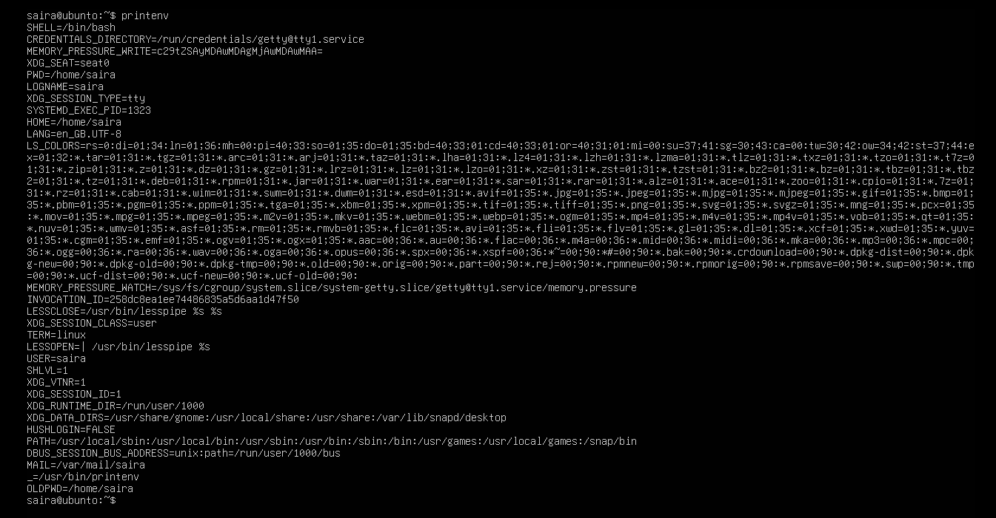
- Filter for SHELL, HOME and USER — run these greps together and capture one combined screenshot:
printenv | grep SHELL
printenv | grep HOME
printenv | grep USER
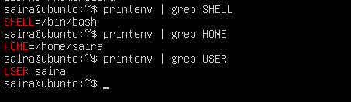
Task 2 — Export DB_* variables temporarily and observe scope
Goal: Create env variables with export in the current shell, verify them, then close shell and show variables are gone.
Steps:
- Define all DB_* variables (run the three exports one after another). Capture them in one screenshot showing the three export commands and their execution:
export DB_URL="postgres://db.example.local:5432/mydb"
export DB_USER="labuser"
export DB_PASSWORD="labpass123"
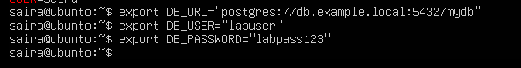
- Echo the three variables (run the three echo commands together) and capture one screenshot showing their outputs:
echo "$DB_URL"
echo "$DB_USER"
echo "$DB_PASSWORD"
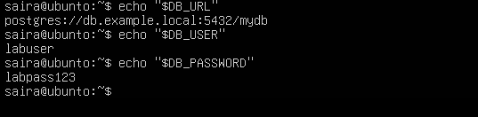
- Show all DB_ variables with a single grep command (capture that output):
printenv | grep '^DB_'
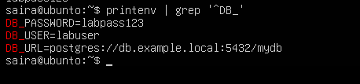
- Close the bash session (e.g., exit) and reopen a new terminal. Verify the variables are gone by running the echo(s) and the grep together; capture both checks in one screenshot:
echo "$DB_URL"
printenv | grep '^DB_'
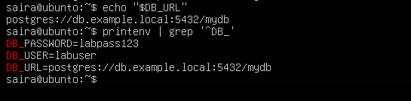
Optional combined evidence (if you want to also save a combined screenshot showing steps 1–3 together for convenience):
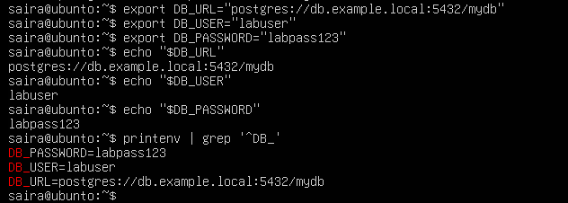
Task 3 — Make DB_* variables persistent in ~/.bashrc
Goal: Add DB_* variables to ~/.bashrc, reload, and verify persistence. Grouped captures:
show the three export lines in ~/.bashrc together, and group the post-source checks into one screenshot.
Steps:
- Open ~/.bashrc in an editor and append the three export lines. Capture the editor showing the three lines added (single screenshot):
vim ~/.bashrc
# add at the end:
# Lab 7 persistent DB variables
export DB_URL="postgres://db.example.local:5432/mydb"
export DB_USER="labuser"
export DB_PASSWORD="labpass123"
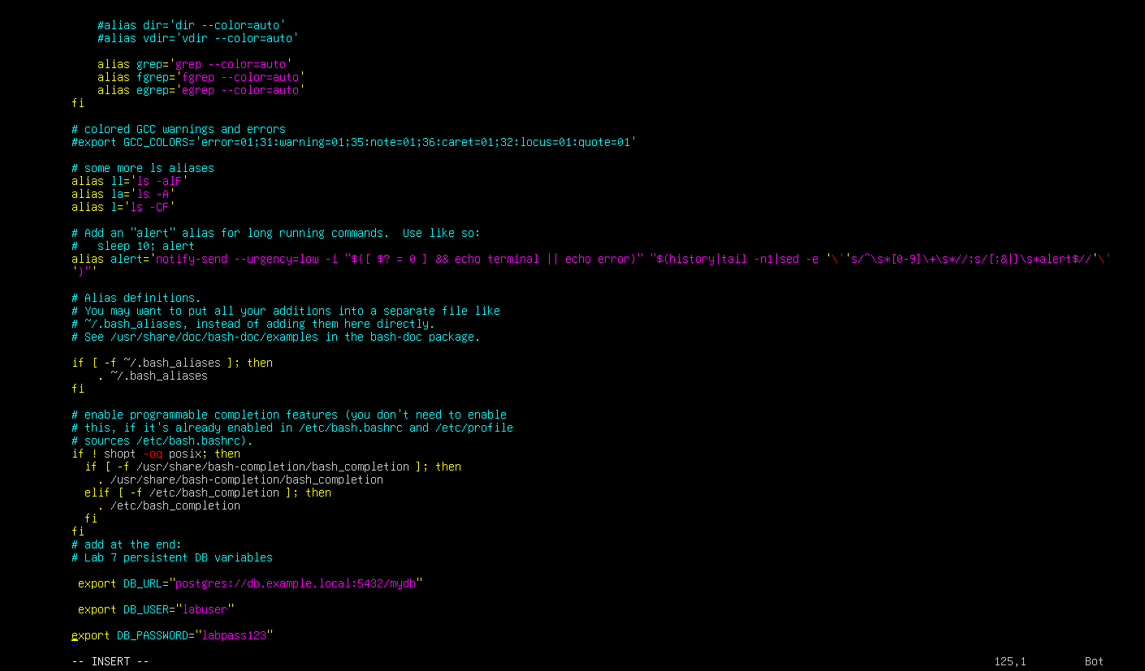
- Source ~/.bashrc and capture the source command in one screenshot together with the next verification commands (grouped): run source ~/.bashrc and then immediately run the three echoes and a single grep, capturing all of these in one screenshot:
source ~/.bashrc
echo "$DB_URL"
echo "$DB_USER"
echo "$DB_PASSWORD"
printenv | grep '^DB_'
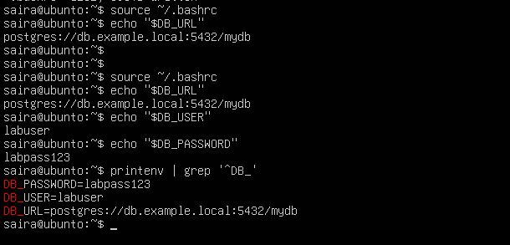
- Close and reopen terminal. Verify persistence by running one echo and the grep together — capture both in one screenshot:
echo "$DB_URL"
printenv | grep '^DB_'

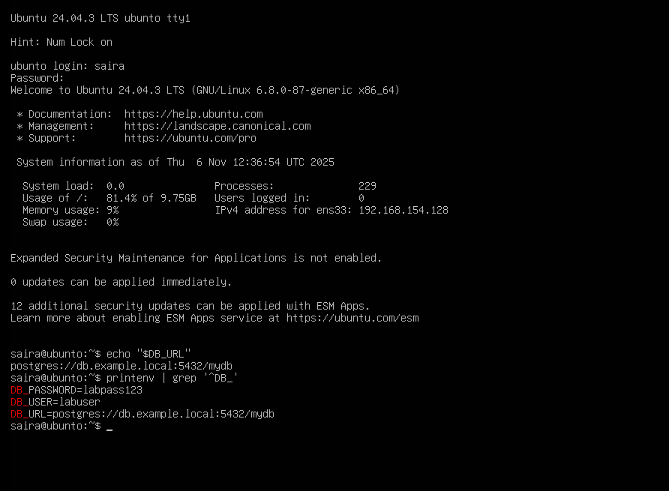
Task 4 — System-wide environment variable, welcome script, and PATH
Goal: Add Class variable to /etc/environment, view PATH, create welcome script on Desktop, make executable, and add PATH entry in ~/.bashrc. Capture grouped screenshots as applicable.
Steps:
- View /etc/environment:
sudo cat /etc/environment
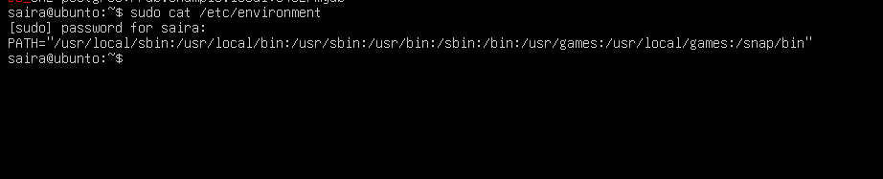
- Show current PATH (single print) — this is not a grep, but keep it as a dedicated screenshot:
echo "$PATH"
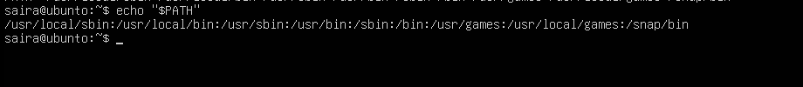
- Edit /etc/environment and add Class:
sudo vim /etc/environment
# add line: Class="CC-<your_class_name>"
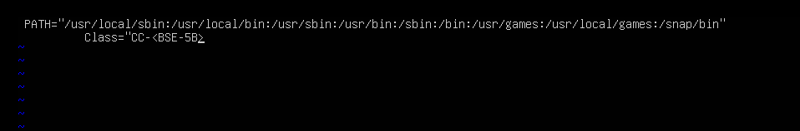
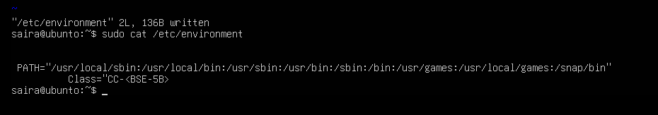
- Re-login or open a new shell and show Class and PATH together (grouped prints): run echo $Class and echo $PATH together and capture in a single screenshot:
echo $Class
echo "$PATH"
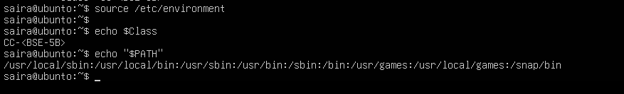
- Create welcome script on Desktop and make it executable (capture the heredoc creation and chmod together in one screenshot if possible):
cat > ~/welcome <<'EOF'
#!/bin/bash
echo "Welcome to Cloud Computing $USER"
EOF

chmod +x ~/welcome
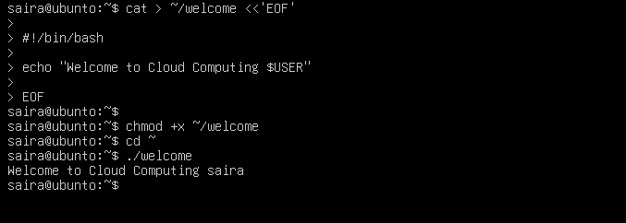
- Run the script from Desktop using ./welcome (dedicated screenshot):
cd ~
./welcome
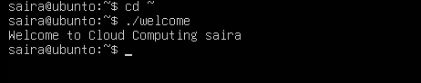
- Add Desktop to PATH in ~/.bashrc (show the editor containing the PATH addition in one screenshot) and then source; capture the source and a single invocation of welcome (from home) together:
vim ~/.bashrc
# add at end:
PATH=$PATH:~/Desktop
export PATH
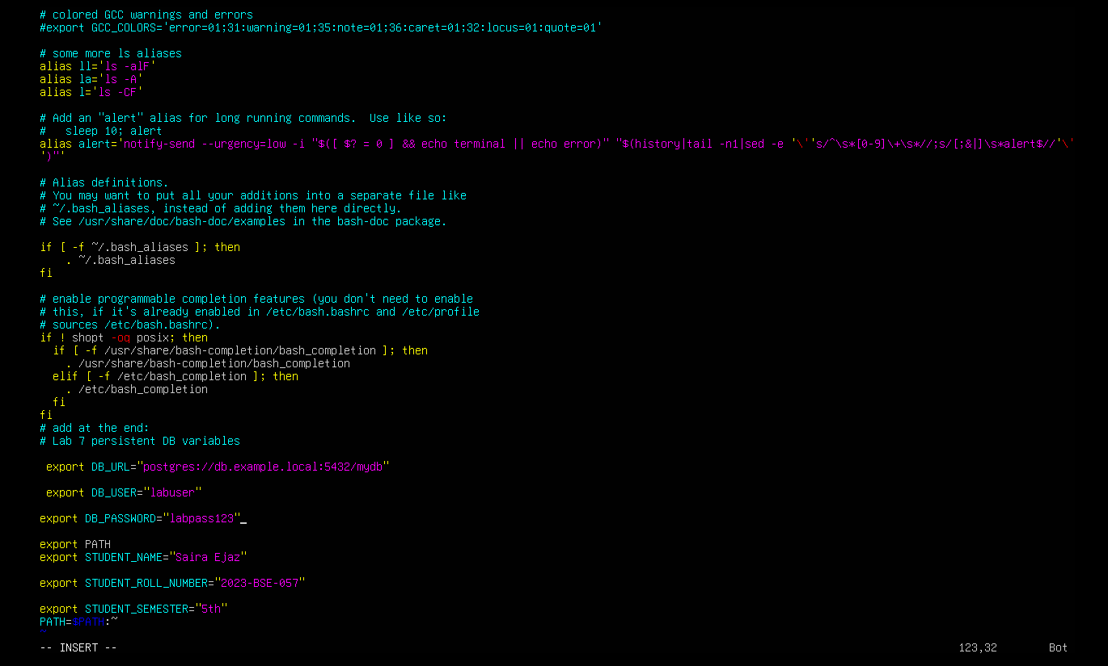
source ~/.bashrc
cd ~
welcome
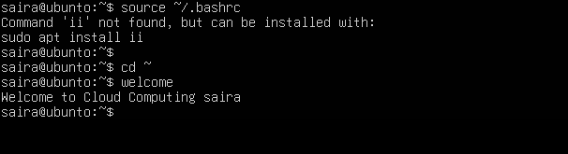
Task 5 — Block and allow SSH using ufw
Goal: Use ufw to deny and allow SSH then verify SSH connectivity changes from host. Save screenshots after each logical command/step; group related print checks when appropriate.
Steps:
- Enable ufw and show status (group both commands in one screenshot if you run them together):
sudo ufw enable
sudo ufw status verbose
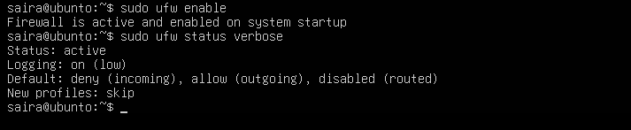
- Deny TCP port 22 and show status (run deny and status numbered together and capture in one screenshot):
sudo ufw deny 22/tcp
sudo ufw status numbered
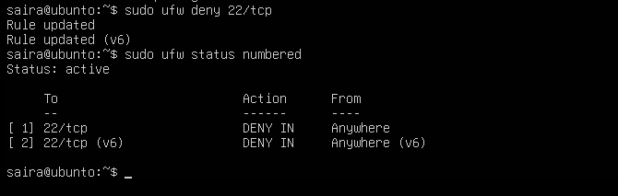
- From Windows host attempt to SSH (expected to fail) — capture the host-side SSH attempt in one screenshot:
ssh username@<server_ip>
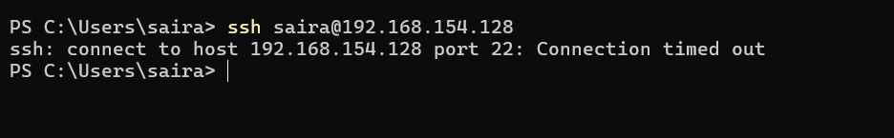
- Allow SSH back and reload, then show status (group allow, reload, status in one screenshot if run together):
sudo ufw allow 22/tcp
sudo ufw reload
sudo ufw status
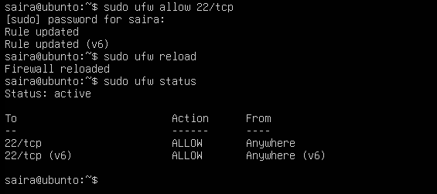
- From Windows host attempt SSH again (should succeed) — capture successful login in one screenshot:
ssh username@<server_ip>
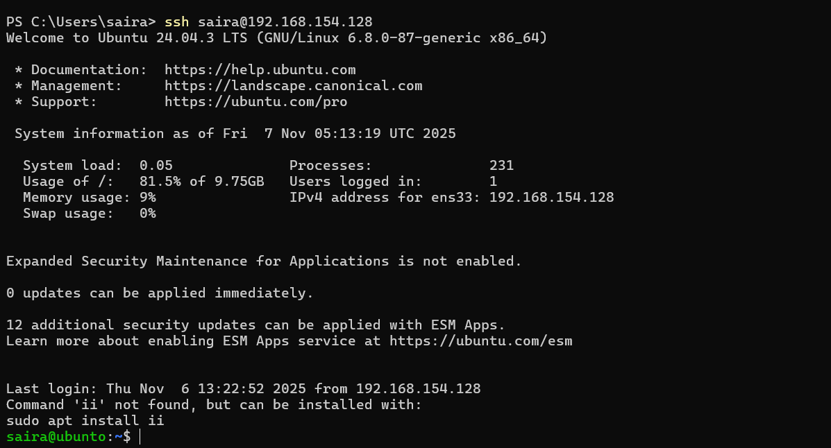
Task 6 — Configure SSH key-based login from Windows host
Goal: Copy your public key from the Windows host into the Ubuntu server's ~/.ssh/authorized_keys to allow passwordless SSH. Save grouped screenshots for the client-side actions and the server-side edits/checks.
A. On Windows host (client) — group related client actions:
- Generate ed25519 key pair (if needed) and show the generated files in one screenshot (run ssh-keygen and then list ~/.ssh):
ssh-keygen -t ed25519 -f ~/.ssh/id_ed25519 -C "lab_key"
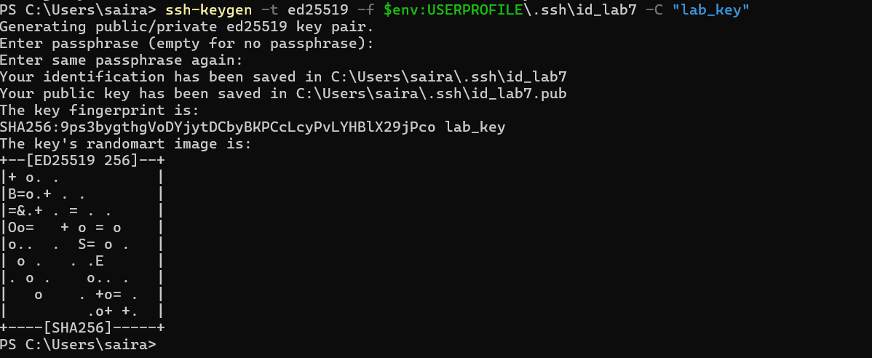
ls -la ~/.ssh
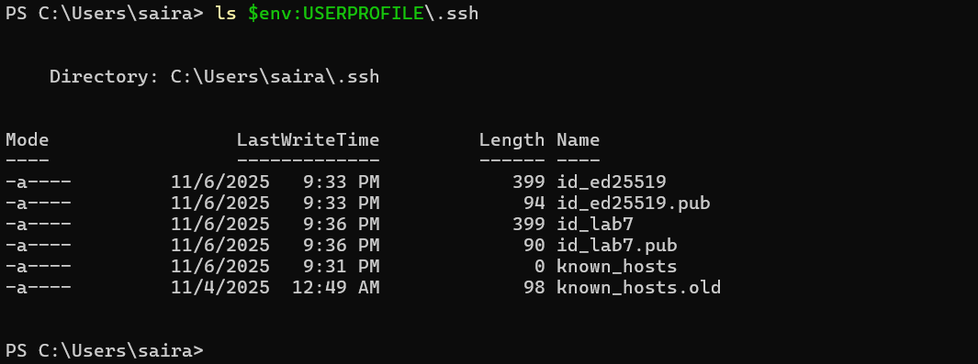
- Show the public key content (single screenshot):
type $env:USERPROFILE\.ssh\id_lab7.pub
# or on Git Bash: cat ~/.ssh/id_lab7.pub
- (Optional) Show known_hosts after first connection (single screenshot):
type $env:USERPROFILE\.ssh\known_hosts
B. On Ubuntu server — group related server-side commands:
- Inspect .ssh and authorized_keys before adding key (capture both outputs in one screenshot):
ls -la ~/.ssh
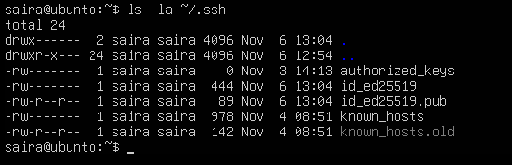
cat ~/.ssh/authorized_keys || true
- Create ~/.ssh, set permissions, append the public key (manual method), and show the resulting authorized_keys — capture the mkdir/chmod/echo and the final cat in one screenshot:
mkdir -p ~/.ssh
chmod 700 ~/.ssh
# paste public key line from Windows client into the echo below (or use ssh-copy-id)
echo "ssh-ed25519 AAAA... yourpublickey ... comment" >> ~/.ssh/authorized_keys
chmod 600 ~/.ssh/authorized_keys
cat ~/.ssh/authorized_keys
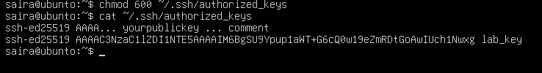
- From Windows host test passwordless login (capture successful login in one screenshot):
ssh username@<server_ip>
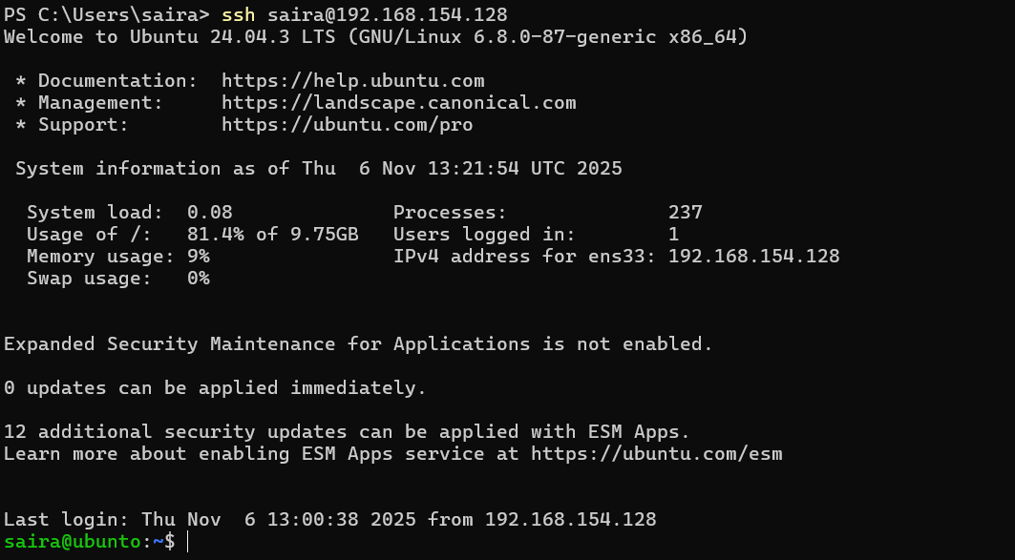
- Also demonstrate explicit identity usage (single screenshot):
ssh -i ~/.ssh/id_ed25519 username@<server_ip>
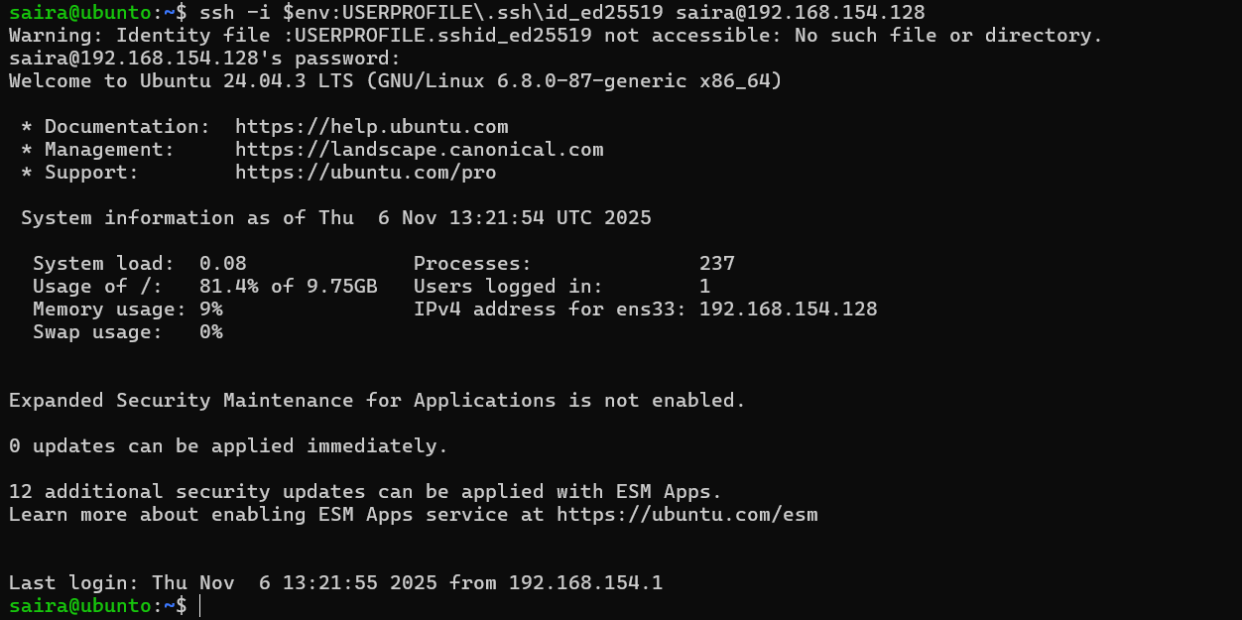
Exam Evaluation Questions
Q1: Quick Environment Audit
- Objective: Demonstrate you can inspect the current environment and extract a few key variables.
- Actions & evidence:
  - Run a single command to display environment variables and capture its output.
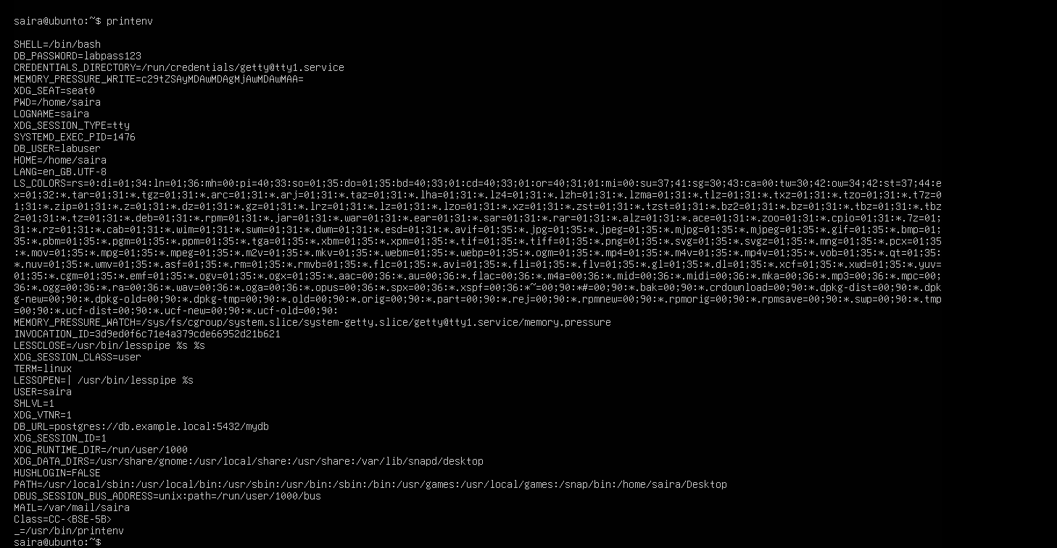
  - In the same terminal session, run three filters (one per line) to show values for PATH, LANG, and PWD, then capture a single screenshot showing the three outputs together.

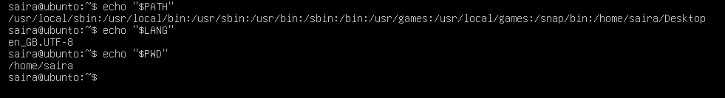
Q2: Short-lived Student Info
- Objective: Show how temporary environment variables behave (session-scoped).
- Actions & evidence:
  - In one terminal, set three variables (STUDENT_NAME, STUDENT_ROLL_NUMBER, STUDENT_SEMESTER) using export — execute all three consecutively and capture them in one screenshot (show the commands executed).
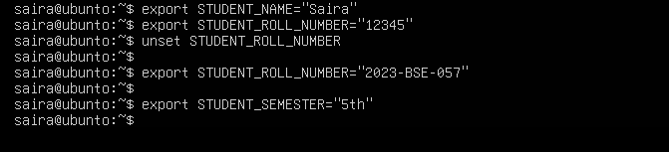
  - Still in the same session, print the three values with echo (grouped) and capture the outputs in one screenshot.
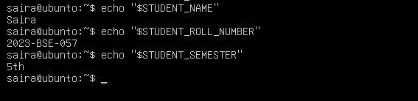
  - Use a single printenv|grep command to list any STUDENT_ variables and capture the result.
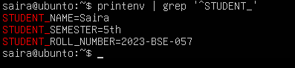
  - Exit that shell, open a fresh terminal, and show that the STUDENT_ variables are not set (use echo and printenv|grep together) — capture in one screenshot.
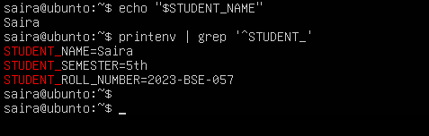
Q3: Make It Sticky (Persistence Check for Student Info)
- Objective: Demonstrate persistence of environment variables across sessions via shell configuration.
- Actions & evidence:
  - Edit ~/.bashrc and append the three STUDENT_* exports. Capture a screenshot of the editor showing the new lines.
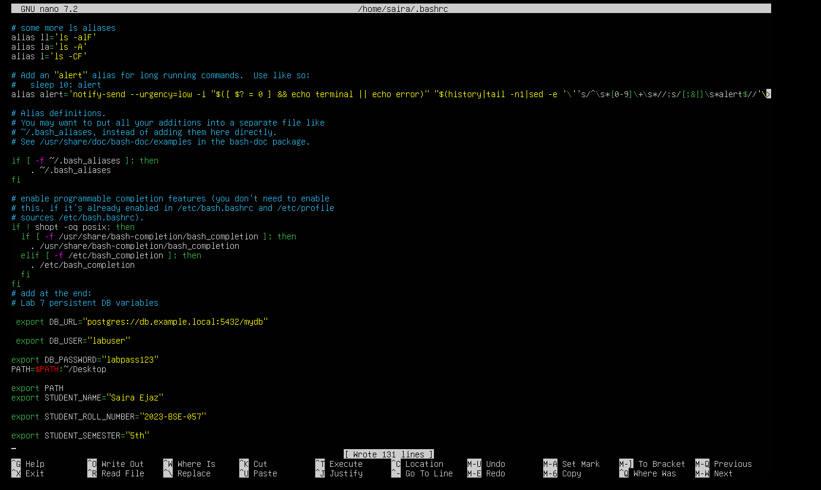
  - Reload your shell config with a single command and then verify the three variables and show printenv | grep '^STUDENT_' — capture these verification outputs together in one screenshot.
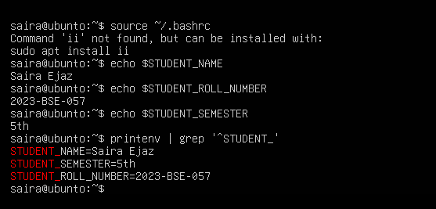
  - Close and re-open a terminal and demonstrate the STUDENT_NAME variable is available (echo and printenv grep together) — capture in one screenshot.
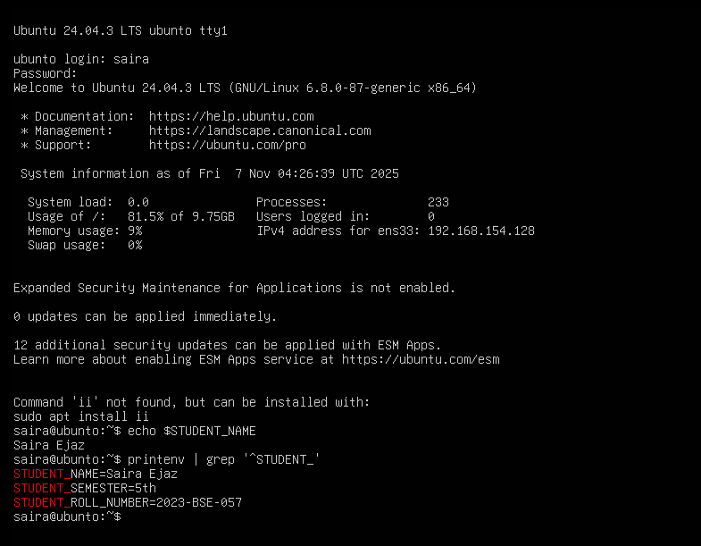
Q4: Firewall Rules: Block and Restore Ping (ICMP)
- Objective: Demonstrate you can block ping (ICMP echo) traffic using ufw and then re-allow it; show effect from a client.
- Actions & evidence:
  - Enable ufw and capture the enable command and status together in one screenshot.
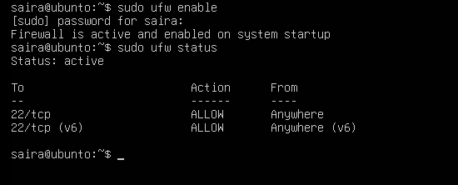
  - Add a rule to block ping (ICMP echo) and show ufw status numbered in the same screenshot.
    - Suggested command example:
    - sudo ufw deny proto icmp from any to any
sudo ufw status numbered
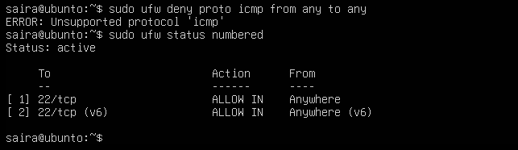
  - From your Windows host (or another client), attempt to ping the server while the rule is active and capture the blocked/failing ping in one screenshot.
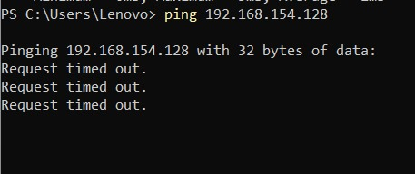
  - Re-allow ping (ICMP) (or remove the deny rule) and capture the allow/reload/status sequence in one screenshot.
    - Suggested command example:
sudo ufw allow proto icmp from any to any
sudo ufw reload
sudo ufw status
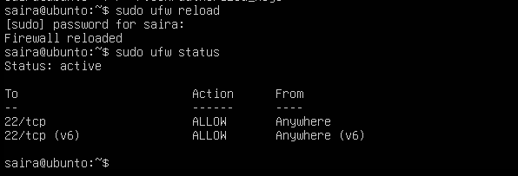
  - From the client, ping the server again and capture successful replies in one screenshot.
